OSSP PRACTICAL 1
OUTPUT

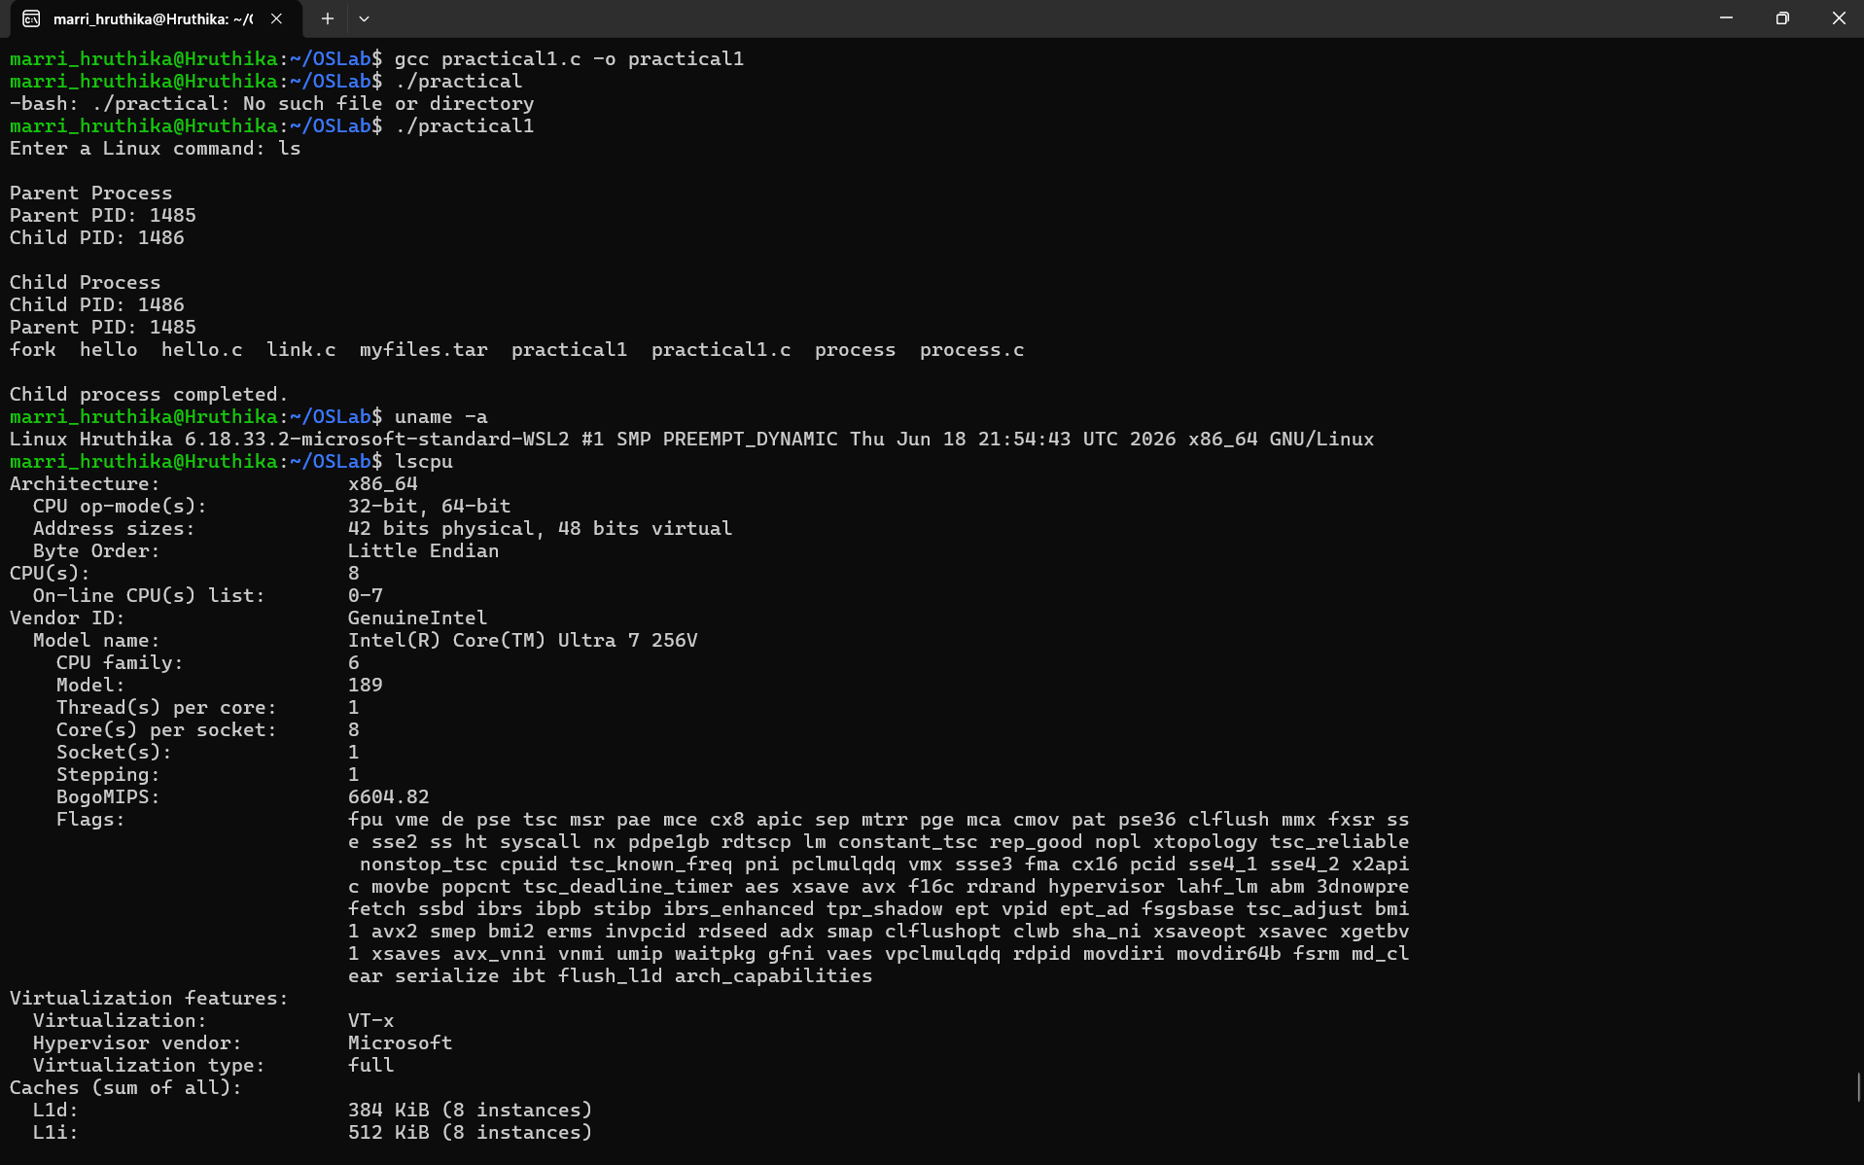
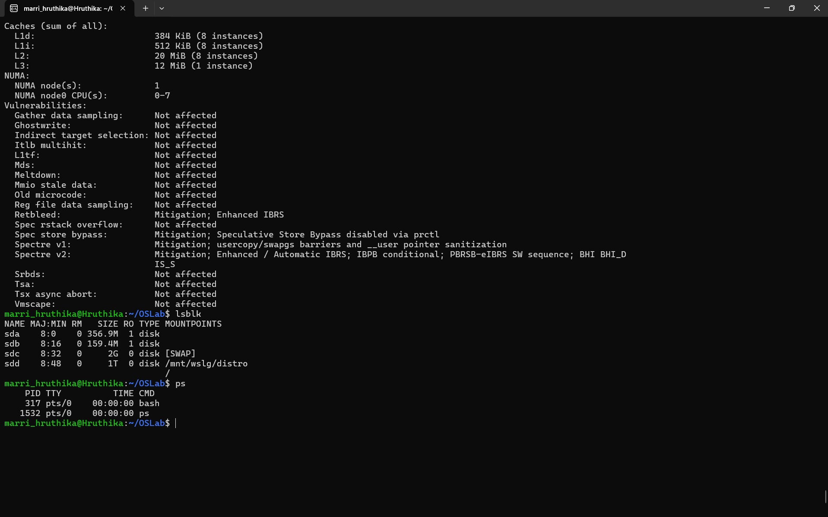
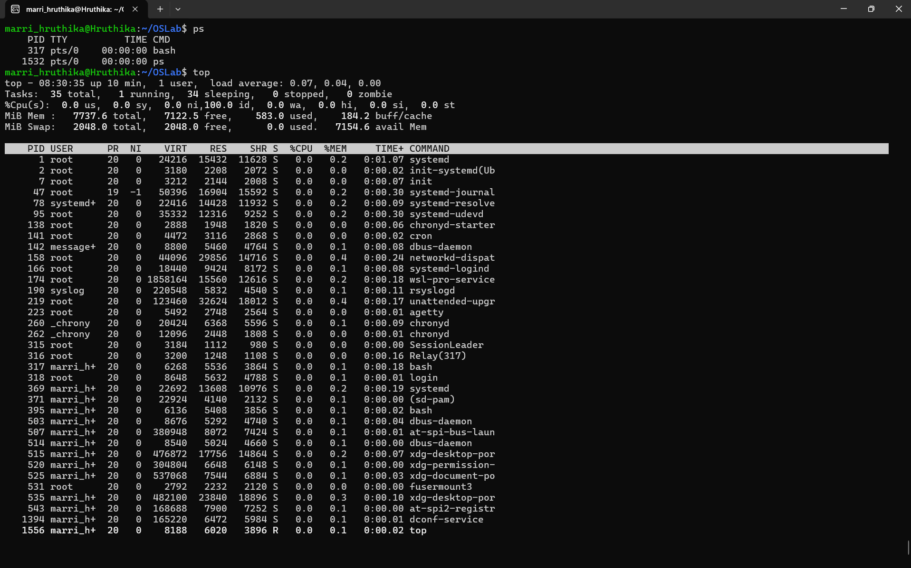

The operating system acts as an interface between hardware and application programs. It manages CPU resources through process scheduling, manages memory through virtual memory, manages storage through files and block devices, and manages I/O devices through device drivers and system calls. Linux provides commands such as lscpu, lsblk, ps, and top to monitor these resources.

Resource Mapping
Hardware | Linux/OS Management
CPU | Process scheduling
Memory | Virtual memory
Storage | Files and block devices
I/O devices | Device drivers and system calls
Processes | PID, scheduling and process states

